Python Interview Questions

### 1. What is Python?

Python is a high-level, interpreted, general-purpose programming language. Being a general-purpose language, it can be used to build almost any type of application with the right tools/libraries.

it has a simple, easy-to-learn syntax that emphasizes readability and therefore reduces the cost of program maintenance. Moreover, the language is capable of scripting, is completely open-source, and supports third-party packages encouraging modularity and code reuse.

2. HLL v/s LLL

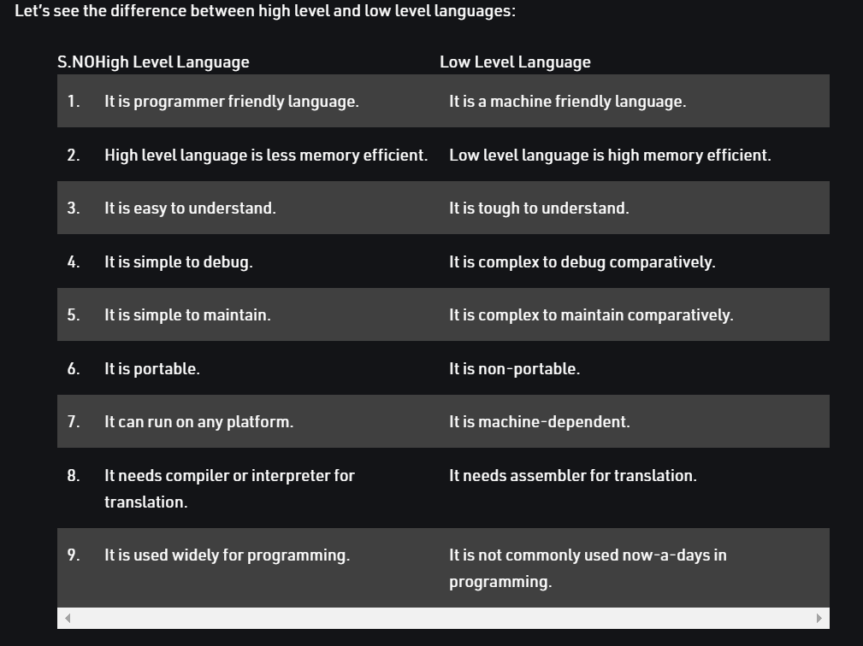

### 3. What is a dynamically typed language?

Before we understand a dynamically typed language, we should learn about what typing is. **Typing** refers to type-checking in programming languages. In a **strongly-typed** language, such as Python, **"1" + 2** will result in a type error since these languages don't allow for "type-coercion" (implicit conversion of data types). On the other hand, a **weakly-typed** language, such as Javascript, will simply output **"12"** as result.

Python is an interpreted language,so it executes each statement line by line and thus type-checking is done on the fly, during execution. Hence, Python is a Dynamically Typed Language.

Note:- An Interpreted language executes its statements line by line.

### 4. What is Scope in Python?

A scope is a block of code where an object in Python remains relevant.

* A **local scope** refers to the local objects available in the current function.
* A **global scope** refers to the objects available throughout the code execution since their inception.

### 5. What are lists and tuples? What is the key difference between the two?

**Lists**and **Tuples** are both s**equence data types** that can store a collection of objects in Python. The objects stored in both sequences can have **different data types**.The key difference is that while **lists are mutable**, **tuples** are **immutable** objects. This means that lists can be modified, appended or sliced on the go but tuples remain constant and cannot be modified in any manner.

**Tuples are more memory efficient than** the lists.

Note:- Dictionary in Python is **an unordered collection of data values.****Dictionaries** are used to store data values in key:value pairs.

Note:- pass keyword represents a null operation in Python